

Moisture Minds Minds M

Team

Green Leaf

Parsec

2023

COSMOSOC, SPACE DATA SCIENCE,

IIT DHARWAD

Table of Contents

**Abstract** 3

**Introduction** 3

**1.1 Importance of soil moisture** 4

**1.2 Problem Statement** 4

**1.3 Objectives** 5

**2.0 Approach towards prediction** 5

**2.1 Data Set** 7

**2.2 Graphs** 7

**3.0 Result and conclusion** 8

**3.1. Model Performance** 8

# **Abstract**

Precise soil moisture prediction is important for water management and logistics of on farm operations. However, soil moisture is affected by various soil, crop, and meteorological factors, and it is difficult to establish ideal mathematical models for moisture prediction. We investigated various machine learning techniques for predicting soil moisture . Specifically, the evaluated machine learning techniques included univariate linear regression, , multiple linear regression (MLR), support vector regression (SVR), Convolutional  neural networks (CNN) and LSTMs. The objective of this study was to determine the effectiveness of these machine learning techniques and evaluate the importance of predictor variables.We have trained the LSTM (Long short term memory) model on the soil moisture dataset which includes data related to soil temperature, Luminous intensity, particulate matter etc.The model accuracy is compared with other models using Mean Square error(MSE) as the evaluation metric.The trained model out performs the existing models with an accuracy of 99.92%.

# **Introduction**

Parsec

Soil moisture refers to the amount of water content present in the soil.Water is the common medium for several life processes. There is no lifecycle without water. Moreover, in plants situation, the uptake of nutrients through the roots is intermediated by soil water. Consequently, water and soil are the elementary requirements for the life and growth of plants.

India is a country where the majority of the population is dependent on agriculture for their livelihood. Indian soils are less fertile, especially in case of micronutrients. In recent years, they have seen that soil health is somehow related with the sustainability in the field of agriculture and also the current crop yield levels can be improved by maintaining the fertility of the soil. Water is the primary resource which determines the survival and development of the Earth's occupant. Soil moisture does not only plays an important role in maintenance of plant growth but also as a key link to the water cycle of soil-plant-atmosphere continuous systems.

However, soil moisture involves complicated structural characters and meteorological factors, and is difficult to establish an ideal mathematical model for soil moisture prediction. Prediction of soil moisture in advance will be useful to the farmers in the field of agriculture.

In the present investigation, we have come up with a solution for soil moisture estimation using artificial intelligence models, by linking soil moisture to particulate matter, soil temperature, humidity, pressure, luminous intensity which gives better accuracy than the existing models.

# **1.1 Importance of soil moisture**

The amount of moisture or soil water is important to be known because:

* Soil water serves as a solvent and food nutrients carrier to boost in plant growth
* The yield of a crop is determined by availability of the amount of water
* Soil water is a nutrient factor on its own
* Temperature of the soil is regulated by the movement of water in the soil
* Micro-organisms metabolic activities require soil water
* Chemical and biological activities of soil are helped by soil water
* Soil is the principal constituent for the growth of plant

# **1.2 Problem Statement**

Soil moisture is an important variable that affects the growth of crops and the overall health of agricultural lands.Predicting Soil Moisture beforehand can be very useful in various fields, from agriculture to natural disaster management and climate modeling. Predicting soil

Moisture can help us in controlling droughts, they can help farmers in planning their irrigation schedules, seed planting,harvest timing, etc.The task is to predict soil moisture levels at a specific location based on the previous 8 months of soil moisture data along with

temperature, and humidity values at the location.

# **1.3 Objectives**

* To predict the soil moisture requirement for the upcoming next month of a year by using the Machine Learning Algorithms**.**

* To study the machine learning approach for detection of the patterns by using both supervised and unsupervised learning algorithms i.e., SVM, Multivariate Linear Regression, LSTM and Convolutional Neural Networks.

* Obtain the results and compare the model accuracy with existing methods.

# **2.0 Approach towards prediction**

The Model used for prediction is LSTM model.

LSTM is actually a solution that is used to rectify the problem of Vanishing Gradient Problem of Recurrent Neural Network

Long short-term memory networks used in the field of [Deep Learning](https://intellipaat.com/blog/tutorial/machine-learning-tutorial/introduction-deep-learning/). It is a variety of [recurrent neural networks (RNNs)](https://intellipaat.com/blog/tutorial/artificial-intelligence-tutorial/recurrent-neural-network/) that are capable of learning long-term dependencies, especially in sequence prediction problems. LSTM has feedback connections, i.e., it is capable of processing the entire sequence of data, apart from single data points such as images. This finds application in speech recognition, machine translation, etc. LSTM is a special kind of RNN, which shows outstanding performance on a large variety of problems. It doesn’t just use the previous prediction but rather retains a longer-term context which helps it overcome the long-term dependency problem faced by other models. It is worth nothing that this is a very simplistic example, but when the pattern is separated by much longer periods of time.

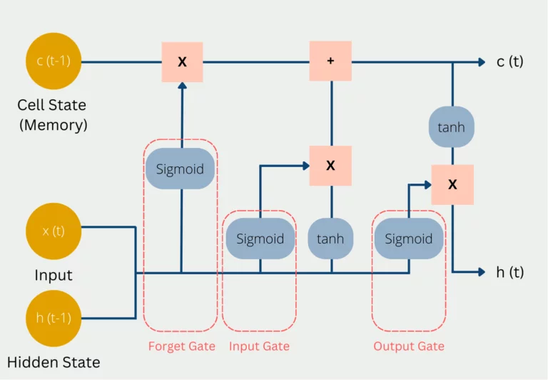

1. In the so-called Forget Gate, it is decided which current and previous information is kept and which is thrown out. This includes the hidden status from the previous pass and the current input. These values are passed into a sigmoid function, which can only output values between 0 and 1. The value 0 means that previous information can be forgotten because there is possibly a new, more important information. The number one means accordingly that the previous information is preserved. The results from this are multiplied by the current Cell State, so that knowledge that is no longer needed is forgotten, since it is multiplied by 0 and thus dropped out.
2. In the so-called Forget Gate, it is decided which current and previous information is kept and which is thrown out. This includes the hidden status from the previous pass and the current input. These values are passed into a sigmoid function, which can only output values between 0 and 1. The value 0 means that previous information can be forgotten because there is possibly a new, more important information. The number one means accordingly that the previous information is preserved. The results from this are multiplied by the current Cell State, so that knowledge that is no longer needed is forgotten, since it is multiplied by 0 and thus dropped out.
3. In the so-called Forget Gate, it is decided which current and previous information is kept and which is thrown out. This includes the hidden status from the previous pass and the current input. These values are passed into a sigmoid function, which can only output values between 0 and 1. The value 0 means that previous information can be forgotten because there is possibly a new, more important information. The number one means accordingly that the previous information is preserved. The results from this are multiplied by the current Cell State, so that knowledge that is no longer needed is forgotten, since it is multiplied by 0 and thus dropped out.

# **2.1 Data Set**

The Data set provided for us is a .csv(comma-separated values) . which contains 7 features of soil namely ttime - timestamp in yyyy-mm-dd format , pm - particulate matter (1,2,3 is categorised into different sizes) ,am - atmospheric moisture, sm - soil moisture, st - soil temperature ,

lum – luminosity , temp – temperature and consist 19341(approx) of data.

# **2.2 Graphs**

1. predictions plot

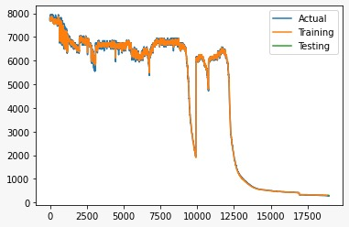

2. Confusion matrix

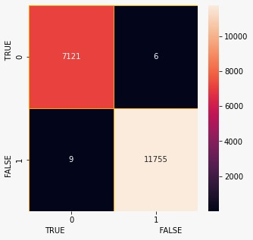

# **3.0 Result and conclusion**

We discussed regarding various important machine learning algorithms and we witnessed that LSTM can be the best possible model for our problem statement as we need to address the time series input with dependencies of previous outputs.

# **3.1. Model Performance**

Machine learning algorithms tested for performance based on the  RMSE, and are presented in Table 1

The best performance was observed under the LSTM   model and has RMSE values of less than 4%.

The RMSE of the predicted soil moisture of five different machine learning algorithm ranges from 0.016 to 0.085 m3 m−3 . The LSTM model outperformed the other models based on the lowest RMSE value of 0.016 m3 m−3.

|  |  |
| --- | --- |
| Algorithms | RMSE |
| Multivariate Linear Regression | 0.059 |
| Support Vector Machine | 0.050 |
| Artificial Neural Networks | 0.085 |
| LSTM | 0.016 |